|  |  |
| --- | --- |
|  | The Renaissance – Did it Herald a Better Life for All? |

# Who were the great men and women of Renaissance times

# My Top 10 Renaissance People

Sort the people into your top 10 and include your reasons for their selection.

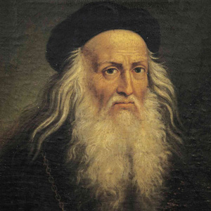 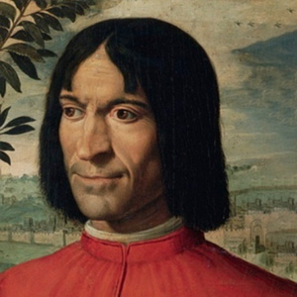 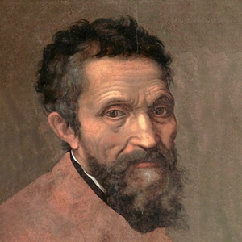 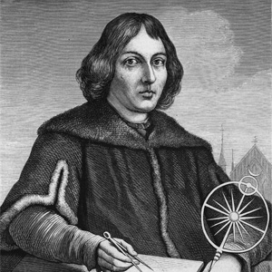 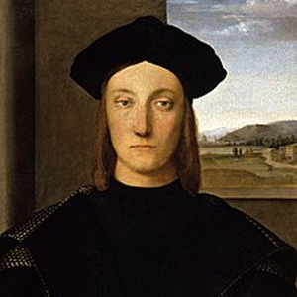 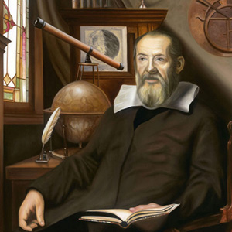  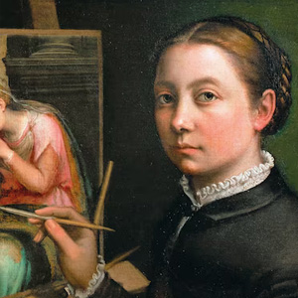 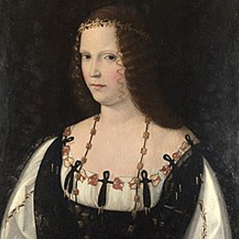 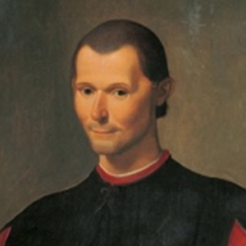

|  |  |  |
| --- | --- | --- |
| **#** | Person | My Reason |
| **1** |  |  |
| **2** |  |  |
| **3** |  |  |
| **4** |  |  |
| **5** |  |  |
| **6** |  |  |
| **7** |  |  |
| **8** |  |  |
| **9** |  |  |
| **10** |  |  |

## Quotes from Machiavelli

Here are some famous quotations from the writings of Niccolo Machiavelli. Read these carefully and then try to think of situations or people today that seem to exemplify Machiavelli’s philosophy of leadership and power.

|  |  |
| --- | --- |
| **Quotes from Machiavelli** | **Historic or current situation or person exemplifying this saying.** |
| *He who wishes to be obeyed must know how to conquer* |  |
| *Politics have no relation to morals.* |  |
| *Never was anything great achieved without danger.* |  |
| *I’m not interested in preserving the status quo I want to overthrow it.* |  |
| *Hatred is gained as much by good works as by evil.* |  |
| *Whoever conquers a free town and does not demolish it may expect to be ruined himself.* |  |
| *War is just when it is necessary; arms are permissible when there is no hope except for arms.* |  |
| *A wise ruler should never keep faith when by doing so it would be against his interests.* |  |
| *When you disarm the people you commence to offend them and show that you distrust them either through cowardice or lack of confidence, and both of these opinions generate hate.* |  |
| *Where the willingness is great, the difficulties cannot be great.* |  |