|  |  |
| --- | --- |
|  | The Renaissance – Did it Herald a Better Life for All? |

# Video Visit: What does Florence today tell us about the Renaissance?

**1.** Who were the Medici?

**2.** Describe what happened to Antonio Rinaldeschi? What does this tell you about life in Florence during the Renaissance?

|  |  |
| --- | --- |
| Law and order |  |
| Religion |  |
| Superstition |  |
| The class system – the popolo grasso and popolo minuto. |  |

**3.** This was not a terribly significant event in Italian history and yet it became the theme for a painting? Why do you think this painting was made? What are the messages or themes in the painting?

**4.** Florence was described as a republic – a form of government in which a state is ruled by representatives of the citizen body. Was Florence a republic in the true sense of the word?

Try to summarise what you have learned from the video by completing this crossword

# Renaissance

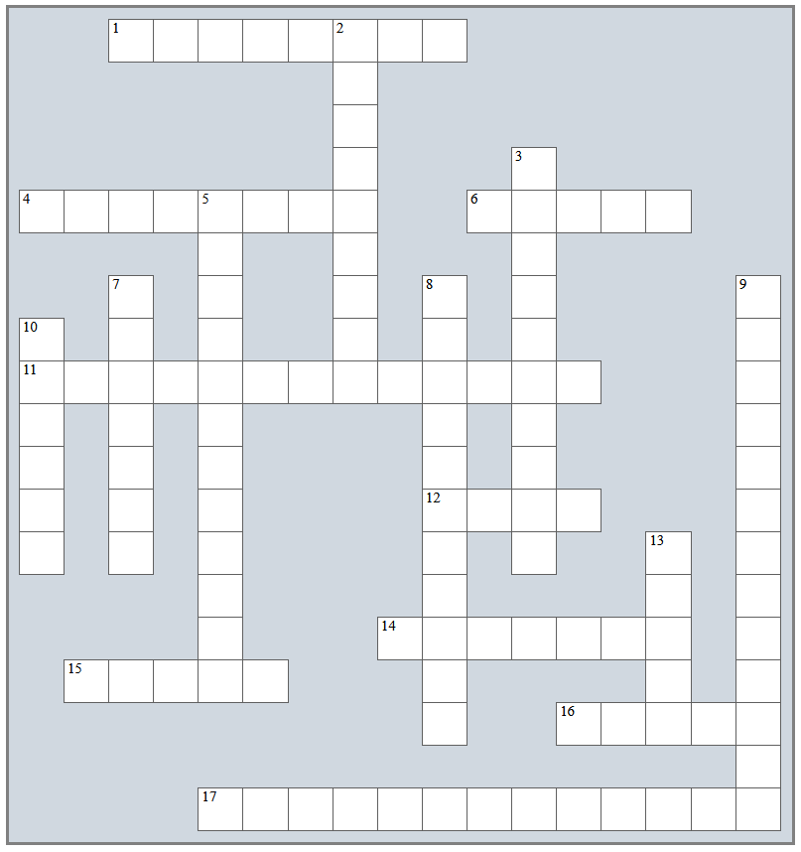

|  |  |
| --- | --- |
| Across  1. Florence’s Golden Gates of ... 2. Official system of government in Florence 3. The family that challenged the ruling family 4. Special Day on which the murder took place in the Cathedral 5. Guild that built the hospital 6. First name of the priest who threw dung at the holy fresco 7. Michael Angelo’s famous statue 8. Florence manufactured and traded 9. Term for the rich people of Florence | Down  1. Babies were left at the Hospital of The ... 2. Priest burned at the stake for heresy 3. A great Renaissance architect 4. Region in Italy where Florence is located 5. Time of rebirth of awakening 6. Florence’s famous bridge 7. The ruling family at that time 8. Name of a famous building in Florence |