 | What are the mysteries of Sutton Hoo?

Investigating the ‘glittering grave goods’ of Sutton Hoo
It is said that every object tells a story. Look carefully at the following objects and photographs and decide what you think they tell you about Anglo-Saxon society.
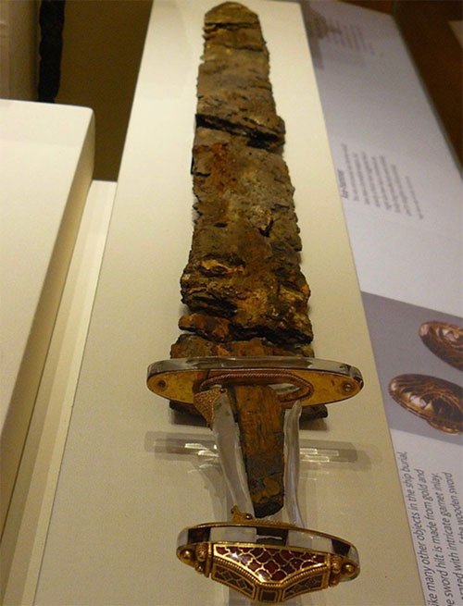  Sword  This object tells me | 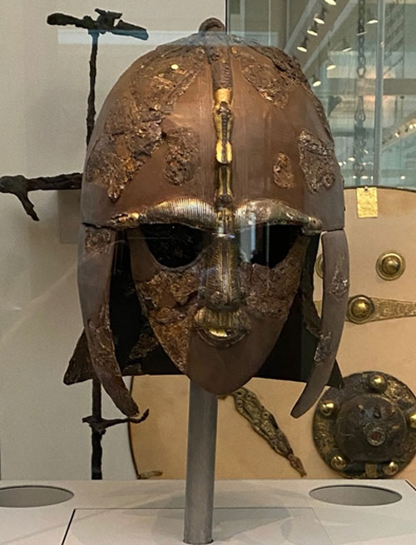  Helmet  This object tells me |  | 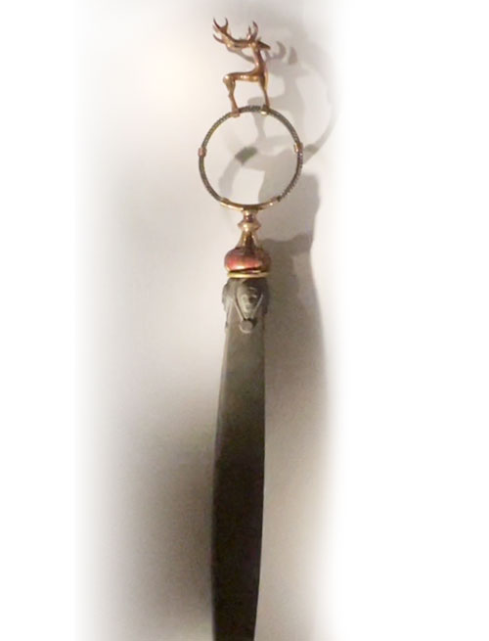  Whetstone sceptre  This object tells me
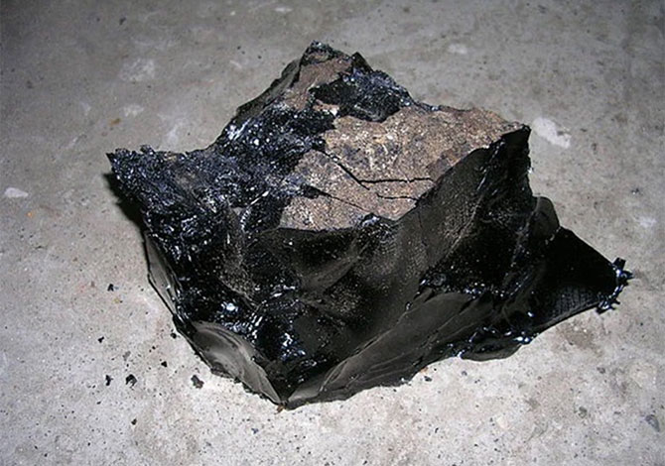  Bitumen - a rare, tar-like material from the Middel East  This object tells me |  | 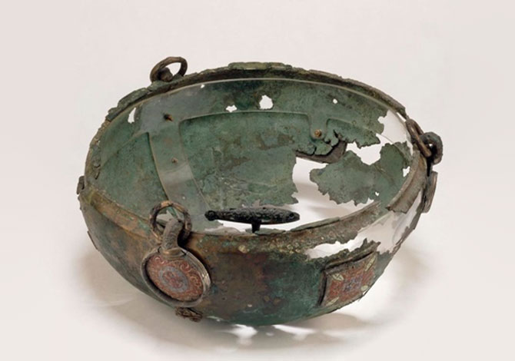  Copper hanging bowl  This object tells me
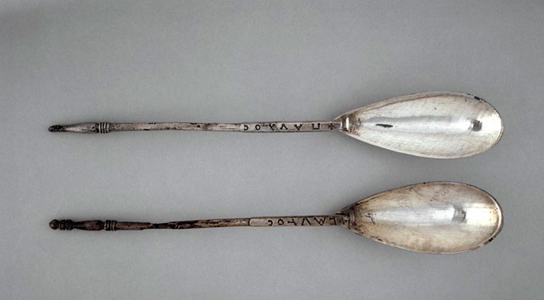  Spoons  This object tells me |  | 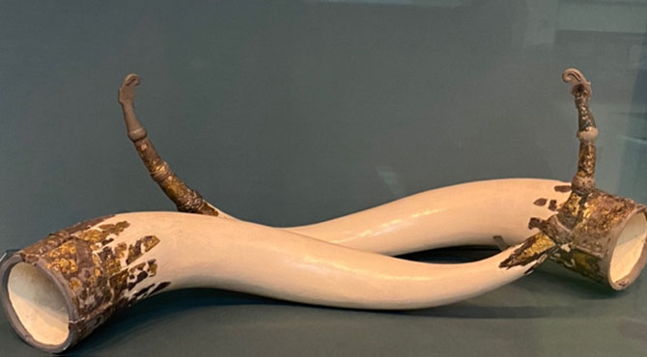  Drinking horns  This object tells me
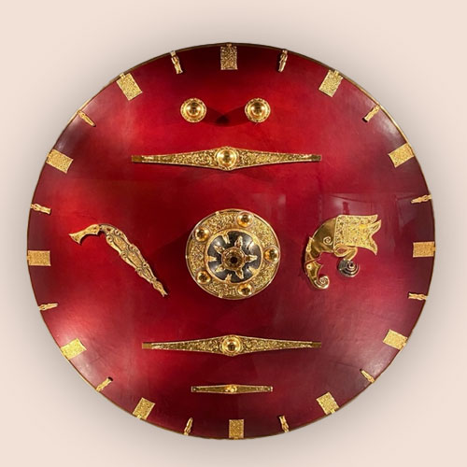  Shield  This object tells me |  | 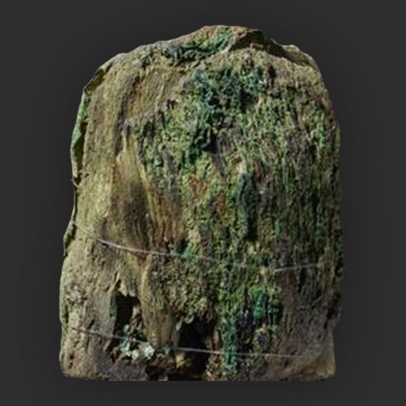  Ivory gaming piece  This object tells me
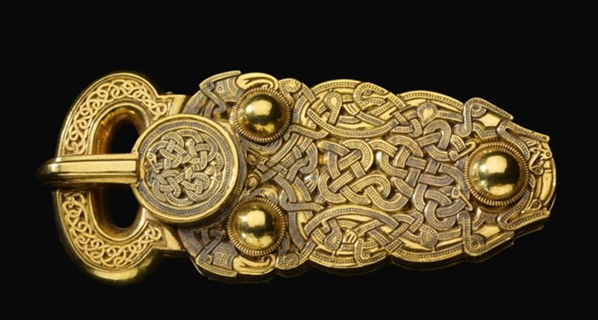  Belt buckle  This object tells me |  | 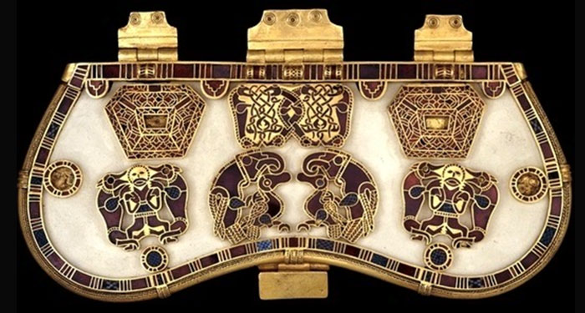  Purse  This object tells me
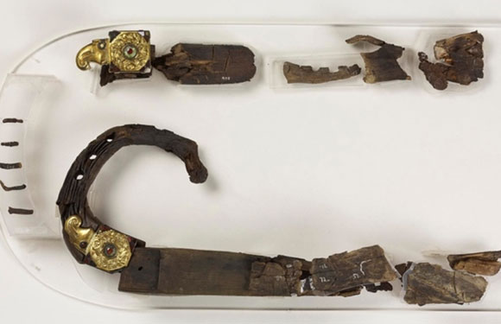  Remnants of the lyre  This object tells me |  | 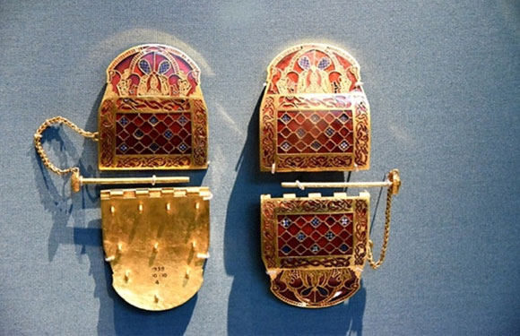  Shoulder clasps  This object tells me

1 What was the significance of finding the rivet?

2 How long was the burial ship? (Delete incorrect answers)
22 metres
27 metres
35 metres
3 From where and how do you think the Anglo-Saxons obtained slaves?

4 Describe the horseman of Sutton Hoo? Does he appear rich or poor?

5 What was the role of a ‘wise woman’ in Anglo-Saxon society? Think back to the video.

6 How skilful were master carpenters? How do we know?

7 How significant were rivers and seas in Anglo-Saxon society?

8 How many oarsmen would be needed to man the ship?

9 Was it an old or new ship when buried?

10 Why did it become known as a ghost ship?

